LAND USE LAND COVER CHANGE DETECTION
OF JHARIA COALFIELD
USING SATELLITE IMAGERY

A Project Report
by
Archita Singh
B.Tech Mining Engineering
Indian Institute of Technology (ISM) Dhanbad

2026

ABSTRACT

This study focuses on analysing Land Use Land Cover (LULC) changes in the Jharia Coalfield for the years 2005, 2015 and 2024 using satellite imagery and Geographic Information System (GIS) techniques. The objective of the study is to identify and quantify the changes occurring in different land use categories over time due to increasing mining activities and urban expansion. Four major land use classes, namely vegetation, mining area, water body and built-up area, were identified through manual digitization using QGIS software. Polygon layers were created for each class, and the area occupied by each category was calculated in square kilometres. Subsequently, temporal change analysis was carried out to compare the spatial distribution of these land use classes across the three study years. The results reveal significant landscape transformations in the Jharia Coalfield, characterized by the expansion of mining and built-up areas, accompanied by a reduction in vegetation cover and water bodies. This study demonstrates the usefulness of remote sensing and GIS techniques for monitoring land use dynamics and provides valuable information for environmental management and sustainable planning in mining regions.

1. INTRODUCTION

Jharia Coalfield, located in the Dhanbad district of Jharkhand, India, is one of the country's most important coal mining regions and is well known for its rich reserves of high-grade coking coal. Over the past several decades, intensive mining activities, rapid industrialization and increasing urban expansion have significantly altered the natural landscape and land use patterns of the area. These changes have affected vegetation cover, water bodies and built-up areas, leading to various environmental concerns such as land degradation and ecological imbalance.
Monitoring and analysing these land use and land cover (LULC) changes is essential for sustainable land management, environmental planning and resource conservation. Remote Sensing and Geographic Information System (GIS) techniques provide efficient, accurate and cost-effective methods for mapping, monitoring, and analysing LULC changes over different time periods, thereby supporting informed decision-making for sustainable regional development.

2. OBJECTIVES

- Prepare LULC maps of Jharia Coalfield.
- Classify land into vegetation, mining, water and built-up areas.
- Calculate the area occupied by each land use class.
- Compare land use changes from 2005 to 2024.

3. STUDY AREA

Jharia Coalfield is located in the Dhanbad district of Jharkhand, India, and is renowned for its rich reserves of high-grade coking coal. The region plays a crucial role in the country's coal production and industrial development. Over the past few decades, rapid expansion of mining activities, increasing urbanization and associated infrastructure development have significantly transformed the land use and land cover patterns of the area, resulting in considerable environmental and ecological changes over time.

4. DATA USED

Data | Source
Landsat 2005 | USGS Earth Explorer
Landsat 2015 | USGS Earth Explorer
Landsat 2024 | USGS Earth Explorer
GIS Software | QGIS (Open Source)
Table 1. Satellite data and software used in this study.

5. METHODOLOGY

- Satellite images downloaded from USGS Earth Explorer.
- Images imported into QGIS software.
- False colour composite (FCC) created for visual interpretation.
- Polygon shapefile prepared for digitization.
- Manual digitization performed on-screen.
- Four LULC classes identified: Vegetation, Mining, Water Body, Built-up.
- Area of each polygon calculated using the field calculator.
- Area statistics compiled and tabulated.
- Temporal change analysis performed across all three periods.

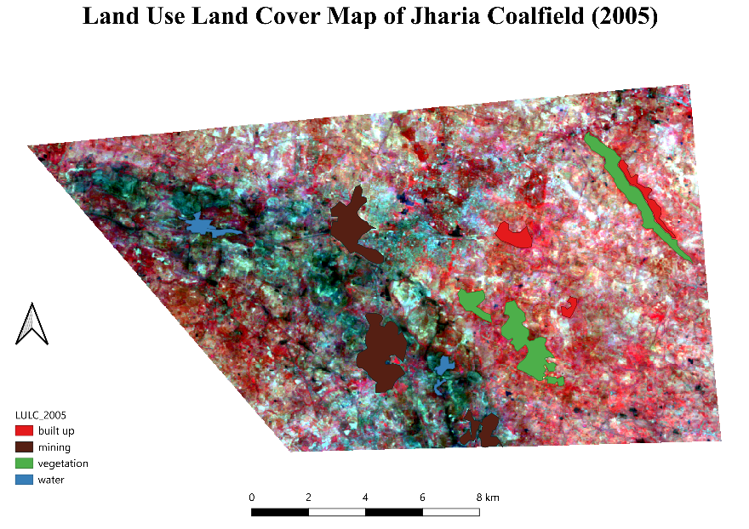

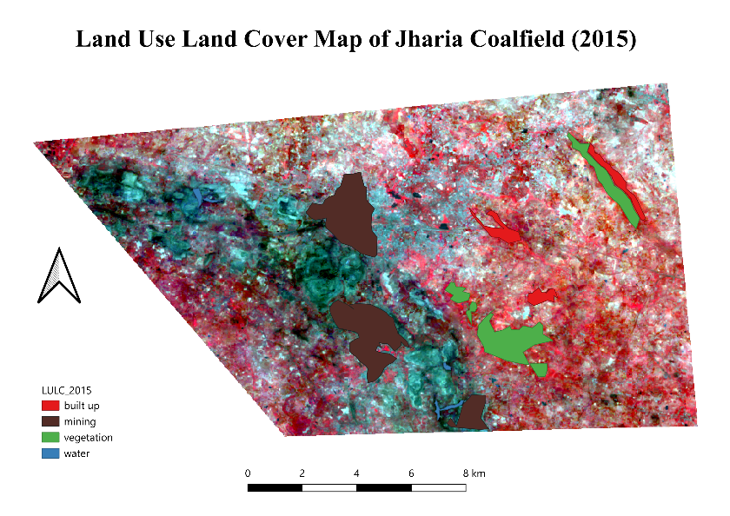

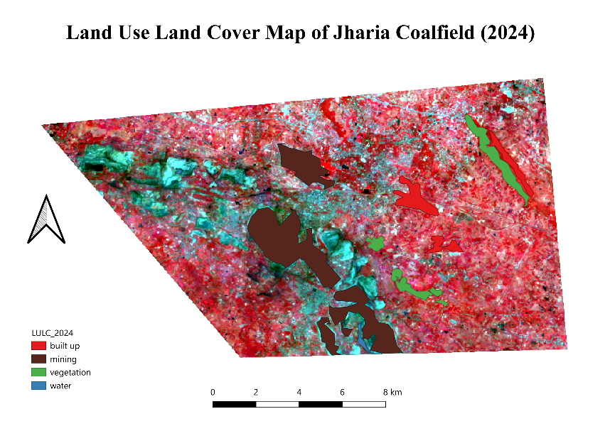

6. AREA STATISTICS

Land Use Class | 2005 (km²) | 2015 (km²) | 2024 (km²)
Vegetation | 5.42 | 5.02 | 3.53
Mining | 6.58 | 10.27 | 15.28
Water | 1.01 | 0.38 | 0.23
Built-up | 1.67 | 2.03 | 3.23
Table 2. Area statistics of LULC classes (km²) for 2005, 2015 and 2024.

7. CHANGE ANALYSIS

Land Use Class | 2005–2015 (km²) | 2015–2024 (km²) | 2005–2024 (km²)
Vegetation | -0.40 | -1.49 | -1.89
Mining | +3.69 | +5.01 | +8.70
Water | -0.63 | -0.15 | -0.78
Built-up | +0.36 | +1.20 | +1.56
Table 3. Change in LULC area (km²) across time periods. Red = decrease, Green = increase.

8. RESULTS AND DISCUSSION

The results indicate a significant increase in mining area from 6.58 km² in 2005 to 15.28 km² in 2024, representing an increase of 8.70 km² over the study period. This substantial expansion reflects the intensified coal extraction activities in the Jharia region.

Vegetation area decreased considerably from 5.42 km² to 3.53 km², a reduction of 1.89 km², demonstrating the adverse impact of mining expansion on green cover.

Water bodies also declined sharply from 1.01 km² in 2005 to just 0.23 km² in 2024, a loss of 0.78 km², likely due to encroachment by mining activities and sedimentation.

Built-up area increased from 1.67 km² to 3.23 km², an addition of 1.56 km², indicating urban growth around the mining regions driven by an expanding workforce and associated infrastructure development.

9. CONCLUSION

This study demonstrates the effectiveness of Remote Sensing and GIS for monitoring land use changes over multi-decadal periods. The analysis of Jharia Coalfield between 2005 and 2024 reveals a dramatic increase in mining and built-up areas, accompanied by a significant decline in vegetation cover and water bodies. These findings underline the environmental pressures exerted by coal mining and urbanization in the region. Continuous monitoring using satellite imagery is essential for sustainable environmental management and policy planning in Jharia Coalfield.

REFERENCES

- USGS Earth Explorer. https://earthexplorer.usgs.gov
- QGIS Development Team. QGIS Geographic Information System. Open Source Geospatial Foundation Project.

